Experiment 19
Implementation of Naive Bayes classification for Bank Loan prediction
Aim
To implement Naïve Bayes classification for Bank Loan Prediction in Python.
Program
# Bank Loan Prediction using Naive Bayes

import pandas as pd
from sklearn.naive_bayes import GaussianNB
from sklearn.metrics import confusion_matrix, accuracy_score

# Dataset
data = {
'Income': [20000,30000,40000,50000,60000,70000,80000,90000],
'Credit_History': [0,1,1,0,1,1,0,1],
'Loan_Status': [0,0,1,0,1,1,0,1] # 0 = No Loan, 1 = Loan Approved
}

df = pd.DataFrame(data)

# Features and target
X = df[['Income','Credit_History']]
y = df['Loan_Status']

# Model
model = GaussianNB()
model.fit(X, y)

# Prediction
y_pred = model.predict(X)

# Confusion Matrix
cm = confusion_matrix(y, y_pred)
print("Confusion Matrix:\n", cm)

# Accuracy
acc = accuracy_score(y, y_pred)
print("Accuracy:", acc)
Output
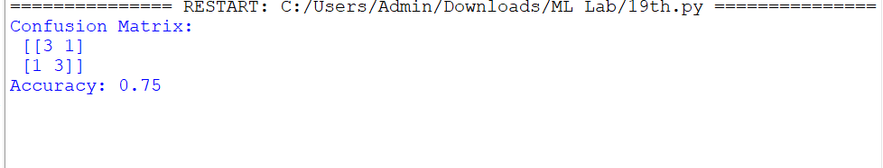

Result
The Naïve Bayes classification model for Bank Loan Prediction was successfully implemented in Python, and the model performance was evaluated using confusion matrix and accuracy score.

